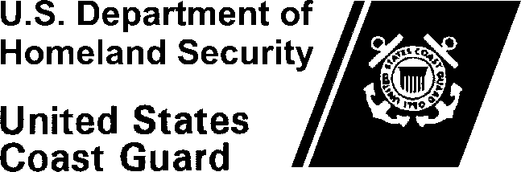

MEMORANDUM
Commander
United States Coast Guard Sector San Juan
Address
Staff Symbol: () Phone: 123-456-7890
Email: John.Doe@uscg.mil
1540
04 May 2020

From: J. Doe, CDR
CG SECTOR San Juan (sl)
To: CG PSC (opm-1)
Subj: VERIFICATION OF PATIENT CARE EXPERIENCE
Ref: (a) Physician Assistant memo AY 2021
- ALCGPSC 057/18
- Performance, Training and Education Manual, COMDTINST M1500.10 (series)
1. This certifies that HS2 Joe Coastie has met and exceeded the prerequisite 100 hours of patient care and has also met and exceeded the prerequisite 40 hours of shadowing a Physician Assistant in a clinical setting set forth by the Physician Assistant Training Program, while assigned to Sector San Juan HSWL since November 2014.

#

